Name :M.Girish

Reg no :192110005 Subject : Management information System CSA4053

3.CONNECTIVITY PROGRAM FOR PAYROLL SYSTEM

FORM:-

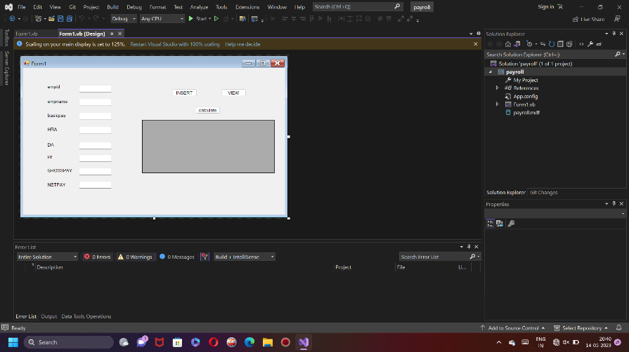

DATABASE:-

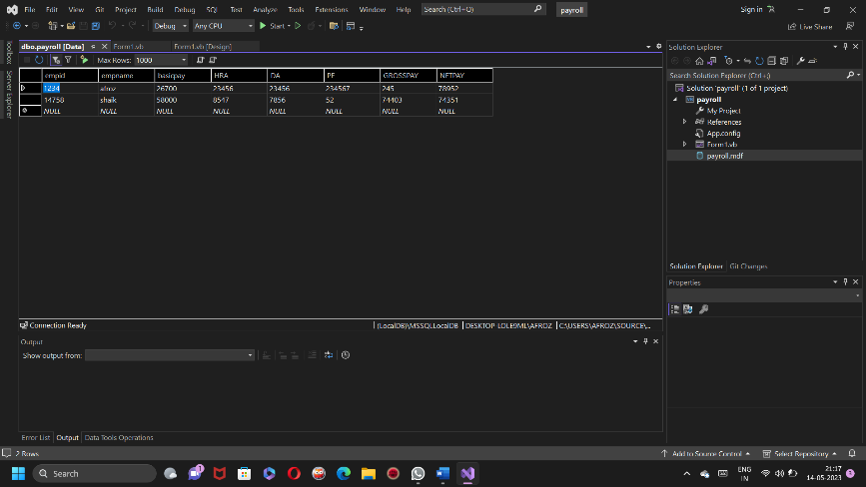

CODE:-

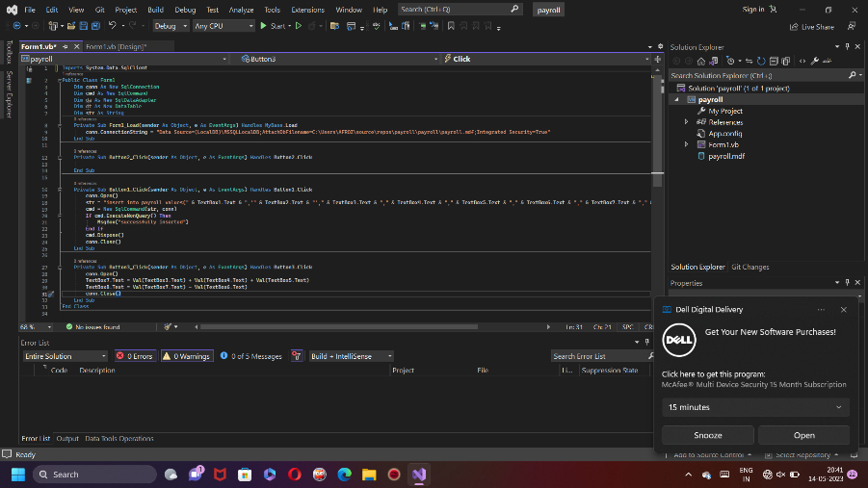

OUTPUT:-

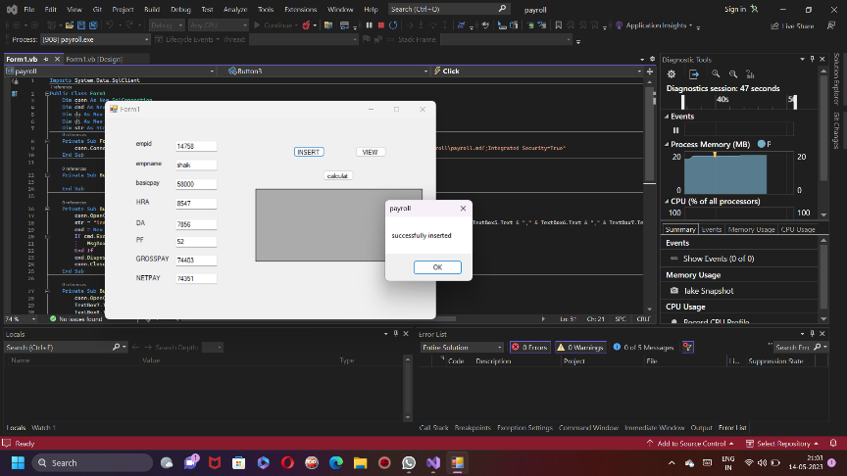

4.CONNECTIVITY PROGRAM FOR STUDENT MARKSHEET

FORM:-

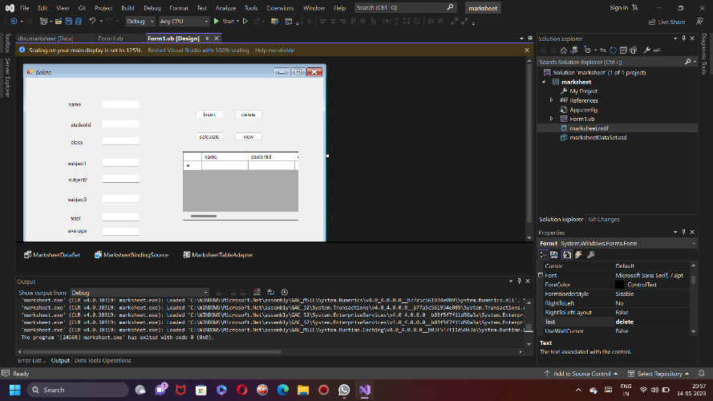

DATABASE:-

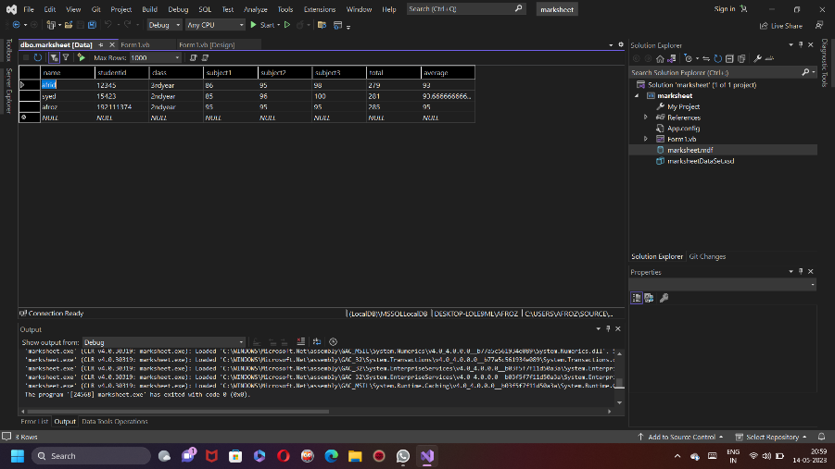

CODE:-

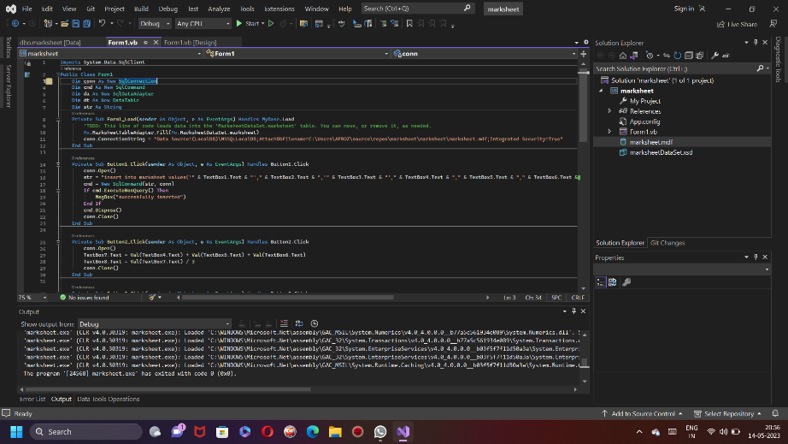

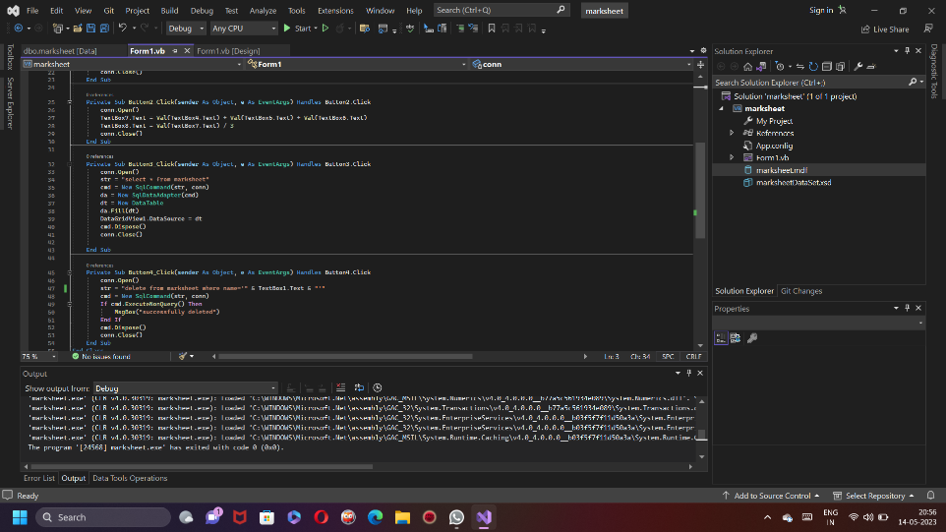

OUTPUT:-

